CMSC 204
Huffman Lab

- Create a Huffman Tree and generate the codes for each character of the following input:
create a huffman tree
For consistency:
- If same frequency – put in priority queue alphabetically; put space before other characters of the same frequency
- Add subtrees to end of group with same priority
- Lower number has higher priority (goes to front)

Now encode “create a huffman tree”

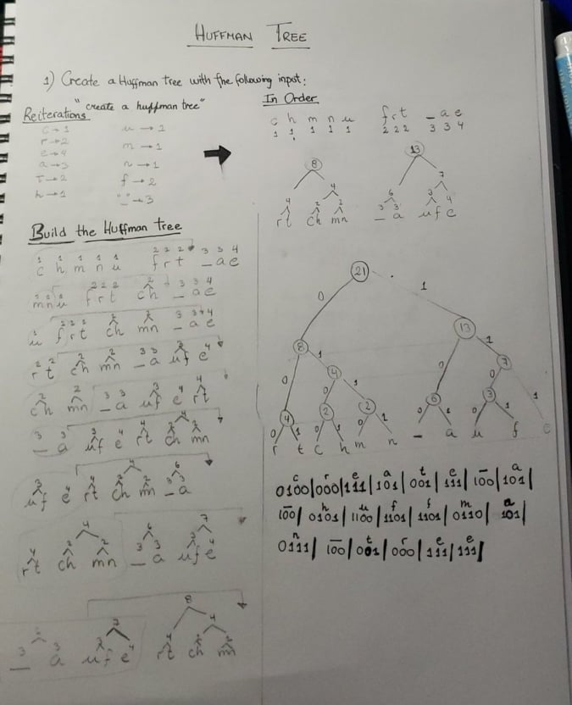
- Based on the following Huffman tree and binary sequence, what is the text

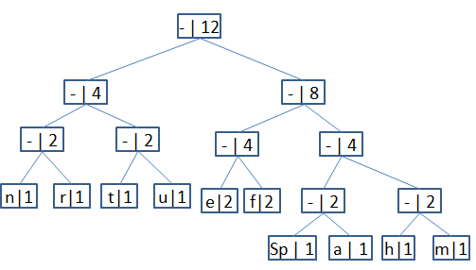

1110|011|101|101|1111|1101|000|1100|010|001|100|100
H U F F M A N _ T R E E

